REFLECTION 1.2
SEQUEL TO THE STORY OF THE RICH YOUNG MAN Due 01/22/19
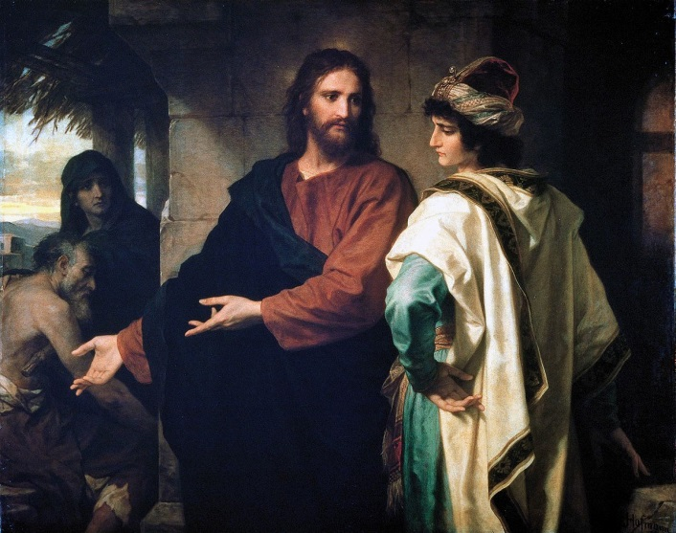

Assignment:
- Read the Gospel story of Jesus’ encounter with the rich young man in Matthew 19:16-23
- Write a sequel to this Gospel story. Imagine what might have happened with this young man after this encounter with Jesus.
  - What did the young man tell his parents, family and friends about his encounter with the teacher, Jesus, who reminded him to “keep the commandments.”?
  - Read further in this Gospel chapter, and see what Jesus told his disciples about the distraction that wealth can cause us as we journey through life.
  - What did this young man do after he walked away from this encounter with Jesus. While he left very sad, did he reflect and repent, turning his life around, or did he go in the opposite direction, drawing further-and-further away from Jesus, and deeper into selfishness.
  - Write your own end of this story. Use your imagination.

Format:
- Your paper:
- Must be typed, double-spaced, with 1-inch margins.
- The paper must be two-full pages.
- The first line of this reflection will be your name, your class hour, the name of the assignment, and the date. Do not include any other heading such as class name, teacher name, etc.
- Use standard 12 pt. font, no bold or italics (unless emphasizing a point), or other fancy fonts.
- Good usage of the English language contributes to your grade. Your software has a spell check and a grammar check … please use them. I will mark down for NOT capitalizing words that are capital-specific, e.g. Jesus, God, Mass, etc.
- Submit via Turnitin.

