ASSIGNMENT 7.1
WHAT DO THE THEOLOGICAL VIRTUES ‘LOOK’ LIKE?
Due 04/23/19
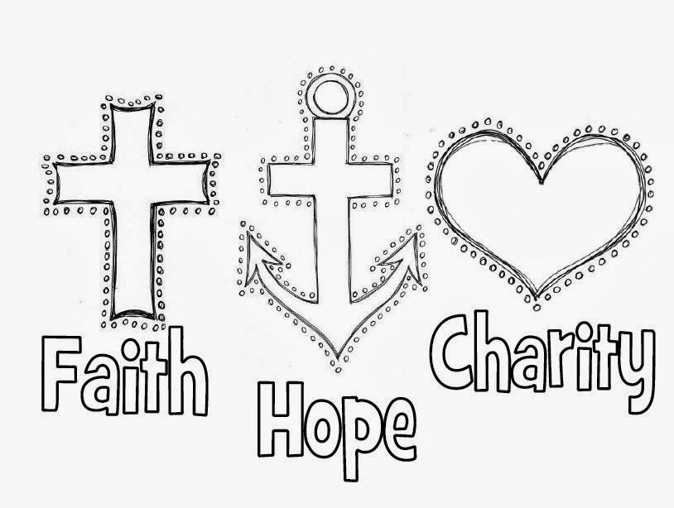

Assignment:
- Make a picture collage of what the three Theological Virtues ‘look’ like to you.

Details:
- Count off in 3’s. The 1’s will work on Faith, 2’s, Hope, 3’s, Charity (also known as Love).
- Begin by familiarizing yourself with your assigned virtue using the text, particularly beginning on page 268.
- Then, using the Pic Collage app (if you don’t already have it, Mrs. Strube can help), you are to create a picture collage using images, people, words, etc. that illustrate for you what that virtue ‘looks’ like. NOTE: You may NOT use images of saints, popes, clergy. Be creative by going outside the norm. I will grade on creativity!
- Secondly, write a paragraph explaining your collage.

Due Date:
- It is due at the beginning of class on Tuesday, April 23, but …
- … you are to work on it IN CLASS TODAY, getting as far as you can prior to the due date.

How you will turn it in:
- On Tuesday, April 23, we will begin the class by having each of you come forward and present your work and explain its meaning.
- You will leave me with the explanation, typed, with your name, assignment name, and class hour on it.

