ASSIGNMENT 7.3
THE POWER OF YOUR NAME
Due Monday, May 6
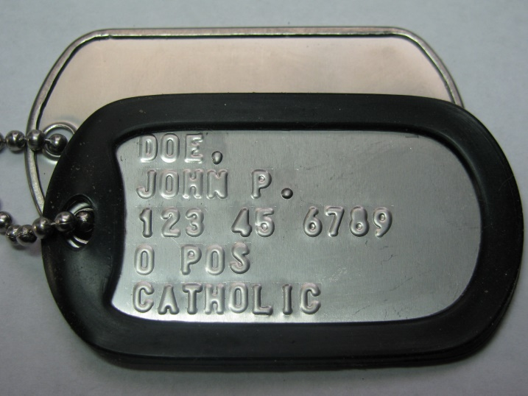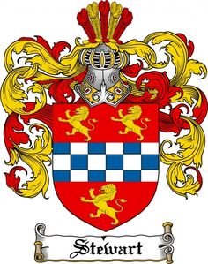

Assignment:
- Using the meaning of names as you find them, first determine your family theme.
- The theme should be at the center of your crest, illustrated in some way by a symbol you choose to make that theme clear (e.g. ‘Strength of God’ could have a cross with a crest of armor).
- Then, the themes of each individual name (your first, middle, Confirmation, Dad’s first, Mom’s first) should surround the main theme symbol.
- Finish the crest in some decorative way.
- Use your imagination!
Crests will be presented and explained in class next week.

Due Date: It is due at the beginning class on Monday, May 6.

Medium: Any, but should be in color

Size: Small poster size

