REFLECTION 8.1
IMMIGRATION CHALLENGE PRESENTATION
Due Tuesday, 05/14/19
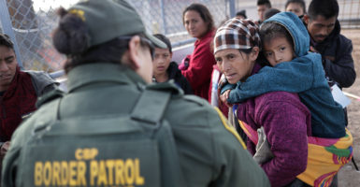

Chapter 8 draws on the Fourth, Fifth, and Sixth Commandments which challenge us to first love and respect ourselves, and then to extend that love to others, even those we may be at odds with or may not know well, or at all.

On Friday, May 10, Sr. Gloria Rivera, IHM shared her experiences of working with immigrants from Mexico and Central America who are caught up in the immigration crisis. Despite our political position on this very politically-charged social issue, the fact remains that innocent people are caught in the middle. Trying to escape poverty and rampant crime in their own countries, these would-be immigrants are drawn to the United States for the same reason many of our ancestors were. As Christians, how are we called to respond to this crisis, and if we feel called, how can those of us so far away actually make a difference?

Assignment:
- Following the presentation, you will prepare a 250 word reflection to include the following.
- What insights did you take away from this presentation, even if you are politically inspired or charged by this issue? Be very clear about your insights, and what you learned or took away from this presentation.
- List a minimum of three action-items that are within your means here in Monroe, to help the plight of the immigrants, particularly those in El Paso, but also those right here in our own area? For each, explain how you would put these into action.

Format:
- Your paper:
- Must answer each of the above questions fully.
- Must be typed, double-spaced, with 1-inch margins.
- The first line of this reflection will be your name, your class hour, the name of the assignment, and the date. Do not include any other heading such as class name, teacher name, etc.
  - over -
- Use standard 12 pt. font, no bold or italics (unless emphasizing a point), or other fancy fonts.
- Good usage of the English language contributes to your grade. Your software has a spell check and a grammar check … use them. I will mark down for NOT capitalizing words that are capital-specific, e.g. Jesus, God, Mass, etc.
- Submit via Turnitin.

