I had a later abortion because I couldn't give my baby girl both life and peace
Kate Carson, Opinion contributor Published 5:00 a.m. ET Feb. 19, 2019 | Updated 12:41 p.m. ET Feb. 19, 2019

No one loves my baby more than I do. Her death was a gift of mercy. Now, women like me will always be a scapegoat for policies limiting women's rights.
People are talking about me again, loudly, unkindly. Even the president of the United States has had his say about families like mine. I have told this story so many times, but I will tell it again as many times as it takes.
I help run a support group for families who have ended pregnancy after poor prenatal or maternal diagnoses. If you’re wondering, “Who are these women who get abortions in the third trimester?” We are. I am. Parents who love our babies with our entire hearts. Desperate acts like an abortion in the 36th week of pregnancy are brought about only by the most desperate circumstances and are only available to those who can come up with a lot of money quickly.
I know. I’ve been there.
My daughter, Laurel, was diagnosed in May 2012 with catastrophic brain malformations (including Dandy-Walker malformation) that were overlooked until my 35th week of pregnancy. I did not know much about brain disorders at that point. I imagined developmental delay, special education classes, financial pressure, an overhaul of expectations for Laurel’s life and my motherhood. Here were the doctors’ real expectations for Laurel: a brief life of seizures, full-body muscle cramps, and aspirating her own bodily fluids.
When I heard the list of all the things my beloved daughter would not do — talk, walk, hold her head up, swallow — I grasped for what she would be able to do.
“Do children like mine just sleep all the time?” I asked.
The neurologist winced. Children like yours, he told me — slowly — are not often comfortable enough to sleep.
Our choice was sad — but clear.
Let me answer some questions you might be thinking: Yes, we were sure that these problems were severe. No, there is no cure, nor any on the horizon. Yes, we were counseled in-depth on our options, including adoption. Because we wanted to spare our daughter as much suffering as possible, our choice was very sad, but crystal clear: abortion.
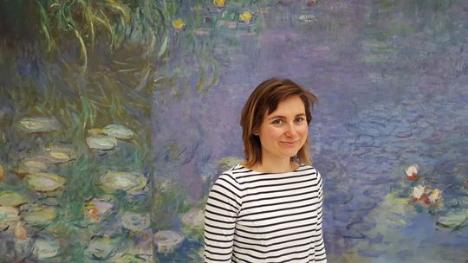
Kate Carson in Paris, France, in 2016. (Photo11: Family handout)

I imagined an abortion at eight months would be grisly. But no matter how violent my imagination, it surely could not compare with the suffering Laurel would have endured in her own broken body.
In Massachusetts, my home state, a later abortion can be obtained only if the life or health of the mother is at risk. So I set off on a 2,000-mile journey from Massachusetts to Colorado to access this abortion. I landed, not in the nightmare I had imagined, but in the safest, kindest, most dignified hands I have ever encountered as a patient anywhere. Dr. Warren Hern at his Boulder Abortion Clinic is one of the few doctors in the country performing this procedure. After a single injection and a couple of hours, my baby was laid to rest in my womb, the purest mercy that I knew how to give my Laurel.
As the usual hubbub of hate and misunderstanding around abortion swelled to a roar this month, the president unfairly addressed families like mine in his State of the Union address. He hasn't really listened to women like me or doctors like Dr. Hern. He seems to care nothing for the true stories of heartbreak, loss and extreme medical complexity behind abortion later in pregnancy. Instead, his agenda must inflate fear and horror until every last American thinks of unspeakable violence.
Mercy means something different to each family.
This is not about abortion. It is about power. This administration needs the public to be angry at women like me and misinformed about what compels women to seek later abortions, which make up less than 1.5 percent of abortions, according to the Centers for Disease Control and Prevention. But I believe that Americans can hear our story and meet the painful, complicated truth about abortions later in pregnancy with love and understanding.
And most Americans have compassion for a woman's choice when it comes to her reproductive health care. In fact, nearly 70 percent of Americans do not want to see the Supreme Court completely overturn Roe v. Wade, according to the Pew Research Center.
Nobody loves Laurel more than I do. Her death was a gift of mercy. Mercy means different things to different loving families, and that has to be OK. To all the families who faced similar circumstances and made a different choice, I honor you. I trust your wisdom. I celebrate your child’s brief and beautiful life.
We must treat each other with love, tenderness and respect. It is horrible, as a parent, to choose between life and peace for our children, especially when we want to give our children both beautiful and precious gifts.
It is devastating to lose a child. But, unlike most bereaved parents, women like me will live out the rest of our lives as scapegoats, fuel for an agenda that seeks to strip women and families of our reproductive freedoms.
When I think of my baby Laurel, I feel love and peace. Unfortunately, I cannot be with that peace because there are fresh wounds in the way, the throbbing pain of being hated and misunderstood.
Kate Carson is a teacher and mother who lives with her family in the Boston area. Kate is a member of NARAL Pro-Choice America.
You can read diverse opinions from our Board of Contributors and other writers on the Opinion front page, on Twitter @usatodayopinion and in our daily Opinion newsletter. To respond to a column, submit a comment to letters@usatoday.com.

